***PROJECT REPORT***

**1.INTRODUCTION**

**TECHPRO has over 16 years of experience in providing technology solutions and products in three areas: (1) Techpro security and building system (SBS); (2) digital printing and data processing (DAP); (3) Construction and maintenance services.**

1.1 OVERVIEW

TechPro IT Solutions, A leading Web Design Company & Digital Marketing Agency with unmatched capabilities & diverse background of building strategic, customizable and insight-driven solutions that maximize Business efficiency & Best ROI.

Our Vision:

We strive to be a trusted partner as an IT Solution provider. We are committed to achieve Customer’s Business Objectives by Delivering Professional Services & adopting Innovative Technologies.

1.2 PURPOSE

* We utilize the latest technology to provide sophisticated and secure IT solutions using an effective delivery model to ensure flexibility and agility. Our specialty of operations includes Application Lifecycle Management, Infrastructure Lifecycle Management and Product Lifecycle Management.
* Techpro can build, design and implement the most advanced software for your organization. Our core competencies are in the area of software development with more than 10 years of experience. We offer top quality tech solutions to small and big companies in India.
* We provide end-to-end solution for all your business needs including web applications, eCommerce websites, mobile apps, offshore development and custom software development. We have worked on numerous projects across various domains like Banking, finance and insurance, eCommerce and retail etc

**2. PROBLEM DEFINITION & DESIGN THINKING**

2.1. EMPATHY MAP

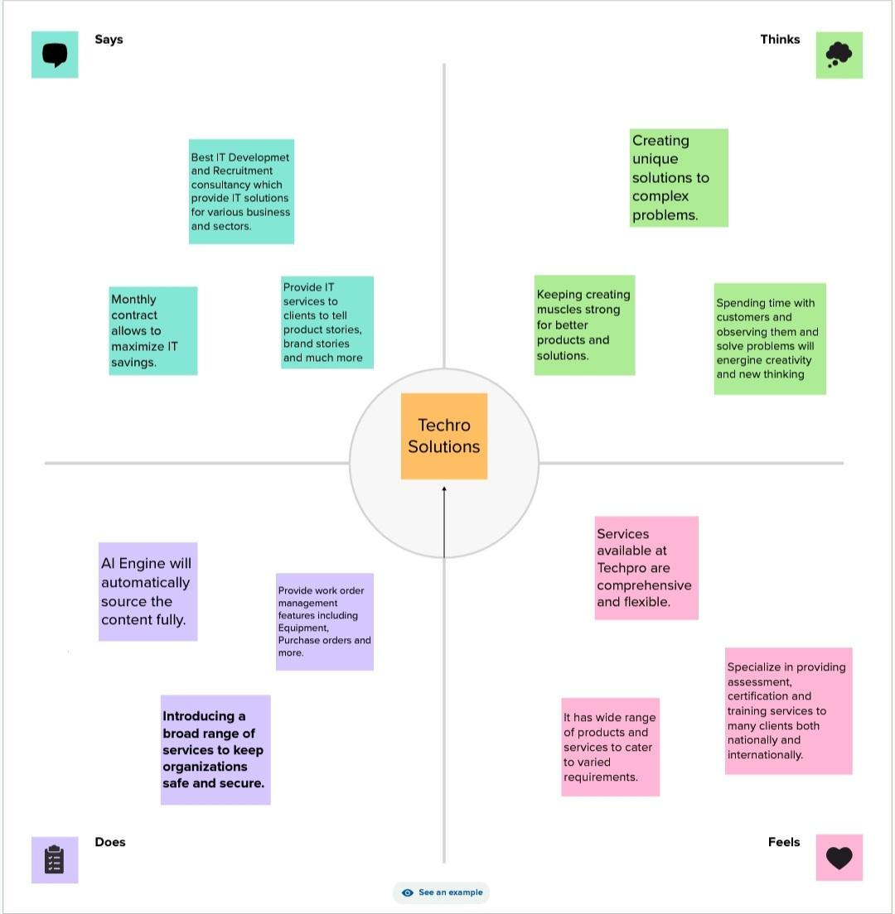

2.2 IDEATION & BRAINSTORMING MAP

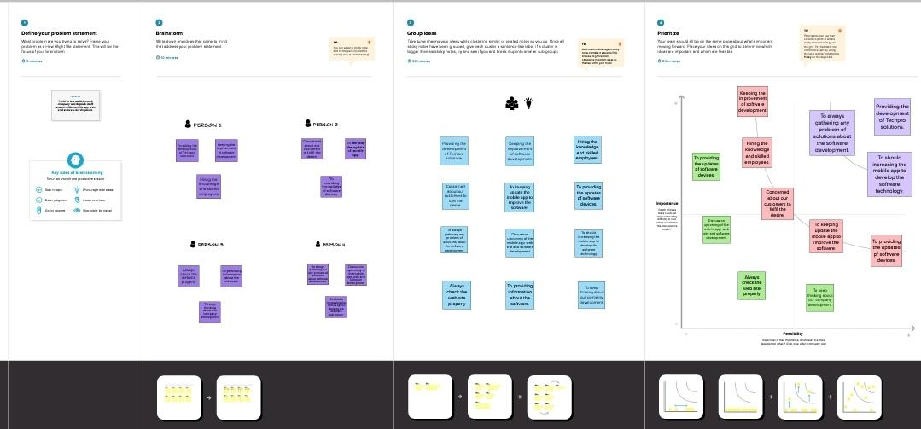

**3.RESULT**

PROFIT & LOSS A/C

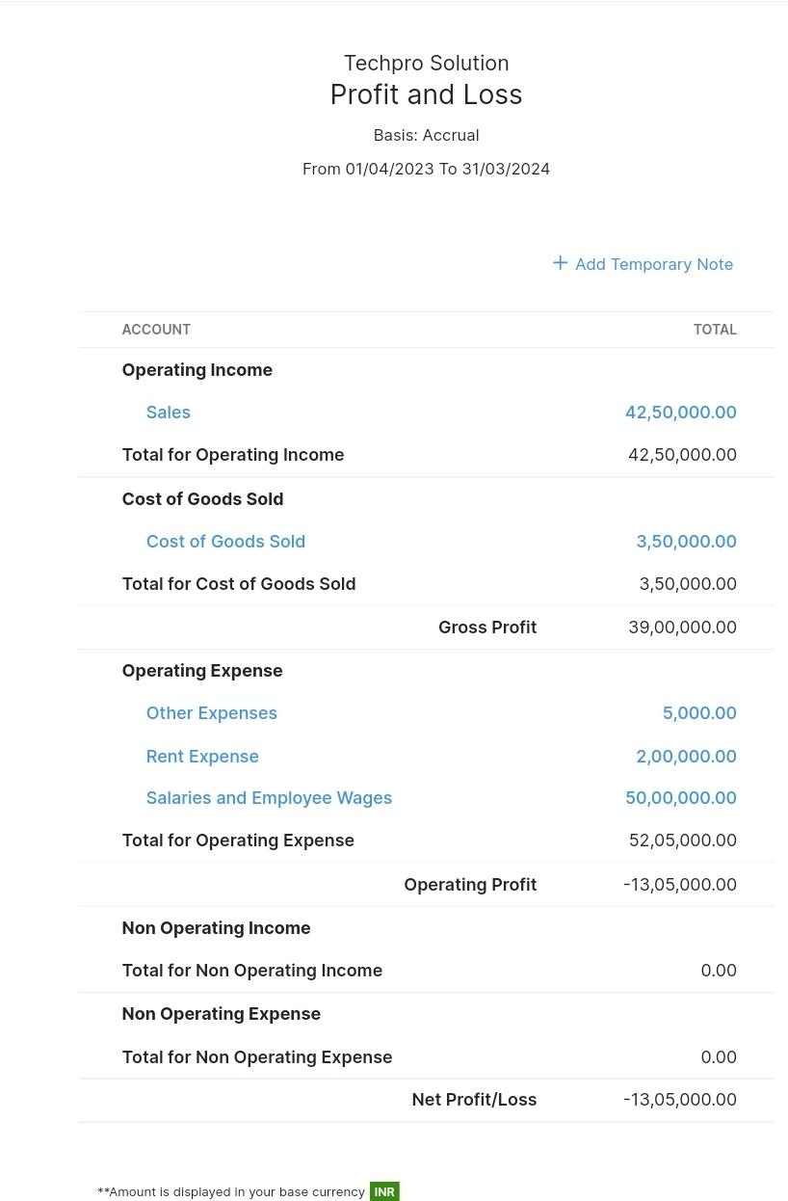

BALANCE SHEET

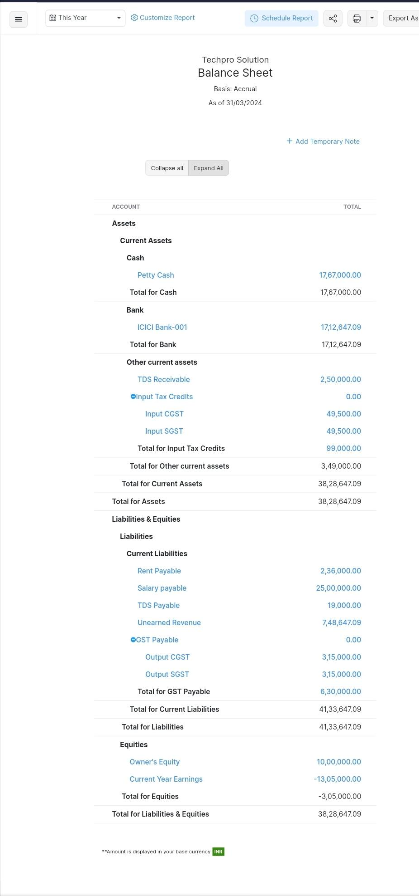

**4.ADVANTAGES & DISADVANTAGES**

ADVANTAGES

GPS tracking:

●High resolution

●More accurate and precise information

●Large amount of information

●Mature technology

●Easy to use and carry

●Can be used worldwide

Timing Systems:

●Non-intrusive

●High resolution

●High sample size

Mobile phone tracking:

●Non-intrusive

●High resolution

●Low-cost

PDA tracking:

●High resolution can communicate with tourists in real-time

●Can track their decision-making process

●Destination cards/ Smart cards with an embedded

chip:

●Non-intrusive

●Easy to use

●High sample size

●Low-cost

Smartphone application based on GPS:

●High resolution

●Easy to use

●High sample size

●Large amount of information

●Low-cost

Bluetooth tracking data:

●Non-intrusive

●High sample size

DISADVANTAGES

GPS tracking:

●Intrusive

●Low sample size

●GPS signals blockage from buildings and foilage

●Long time frame to track tourists

●High risk of loss of GPS equipment

●Difficult survey of motivation

●Limited by battery life

●Expensive

Timing Systems:

●Expensive

●Limited by battery life and data logger memory

Mobile phone tracking:

●Signals blockage from buildings and foilage

●Privacy security issue

PDA tracking:

●Intrusive

●Low sample size

●GPS signals blockage from buildings and foilage

●High risk of loss of equipment

●Expensive

Destination cards/Smart cards with an embedded chip:

●Limited to visit attractions

Smartphone application based on GPS:

●Intrusive

●Signals blockage from buildings and foilage

●Limited to visitors with smartphones

●More accurate in urban areas due to high coverage

●Medium time frame to track tourists

●Privacy security issue

●Limited by battery life

●Difficult survey of motivation

Bluetooth tracking data:

●Limited coverage of sensors

●Detection of all devices belong to visitors and locals

**5.APPLICATION**

● Zoho Books is an online accounting application that takes care of the accounting needs of your business. You can record, audit and analyze all financial transactions easily. Watch this video to get a glimpse into the different modules available in Zoho Books.

● Zoho Books is your one-stop platform for managing your accounting tasks and organizing your transactions. It's a single secure location to keep up with your company's bills and invoices, reconcile your bank statements, control your spending, oversee projects, and eliminate GST compliance worries.

. ● We provide end-to-end solution for all your business needs including web

applications, eCommerce websites, mobile apps, offshore development and custom software development.

● The Zoho CRM can help in reducing the cost by centralized data and free migration integration with a third-party application. It will also increase sales by enabling sales automation. It provides better customer segmentation and automates the sales report.

**USABILITY**

Zoho Books' clean and simple dashboard gives you immediate, convenient insight into your financial health. An effective, user-friendly UI makes Zoho Books easy to navigate.

**RELIABILITY**

Zoho Books is built with dependable features that protect your data and produce accurate results for your accounting. Rely on Zoho Books' customer support team to assist you in making the best use of Zoho Books.

**EXTENSIBILITY**

Zoho Books is designed to help your business connect across multiple platforms. Extend your accounting with a library of more than 300 business apps via Zapier, or take advantage of built-in connections with other apps in the Zoho suite.

**SECURITY**

Zoho Books protects your privacy and security with IP restrictions, two-factor authentication, SSL, and more. Your data can only be accessed by the users that you authorize.

**6.CONCLUSION**

●Zoho Books is a powerful and versatile online accounting software that can help businesses of all sizes manage their finances and streamline their accounting processes.

●Zoho Books allows Indian companies to streamline their GST filing process with its built-in features. It's an end-to-end solution for businesses of all sizes, enabling them to manage their finances more efficiently and effectively.

● Zoho Books Premium's usability, flexibility, and depth in standard bookkeeping areas like sales and purchases, time and project tracking, and inventory management, equals and sometimes surpasses what's offered by competitors.

**7.FUTURE SCOPE**

**●**The consulting services offered by our company help to plan and implement a whole cycle of changes of the company information system. They are aimed to detect and work out recommendations and help to solve customers' business tasks based on knowledge, skills and competence in the fields of management and IT.

●Making use of consulting services can improve competitiveness of your organization due to increase of cooperativeness and quality of personnel response to changing business conditions under strict control of expenses.

●Quality of every work depends, first, on the contractor's competence. Techpro pays special attention to accurate choice and training of consultants which allows us to form a successful team able to implement projects of any difficulty.

OUR SPECIALIST HAVE:

●Vast experience of corporate management system improvement.

●Experience in process description and modeling.

●Vast practice in complex program management.

●Deep knowledge of information technologies.

●Worked-out implementation methods for every task.

The enterprise information system analysis, detection of the most reasonable development trend:

●IT strategy development.

●Development of target corporate information system concept.

●Support of the option and development of future corporate information system.

●Creation of competency centers.